Duration : 1 Hours

Subject : HTML

#-----------------------------------------------------------------------------------------------------------------------

Question 1. Write a HTML program to get the below table. Name this program as q1.html

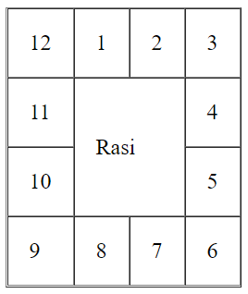

Question 2. Write a HTML program, Create Five Anchor Links such as “Para 1”, “Para 2”, “Para 3”, “Para 4” and “Para 5”, Create Five Paragraphs, Each Paragraph should have 10 lines of text. Apply the styles for all Anchor Links also align the links as shown in the below image. When you click each link then it should take you to the correspond Paragraph in the same document. When you Mouse hover on a link then it should show the Link in Gray background Color. To make it difference, whether any link is already visited or not, Apply text color Yellow only for visited Links. Name this program as q2.html

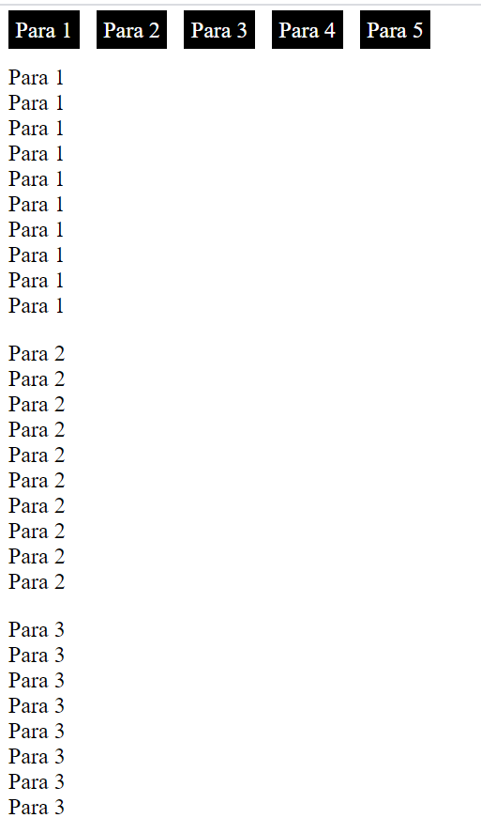

Visted Links are shown as below



